EEEN203 Lab 3 – Hi-Fi Audio Circuit Design

Part 1: Pre-Amp Subwoofer Filter

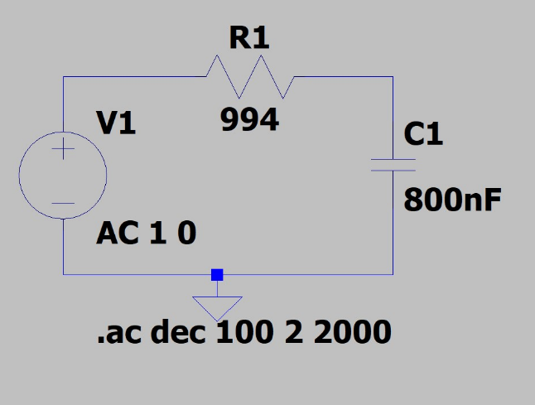Designing the Low pass filter using LTSpice

* Basing off simple capacitor filter; capacitor value needs to be between $100 nF$ and $1 μF$
* $f_{c}$ should be 200 Hz
* For an RC circuit choosing the value 800 nF, the cut-off frequency is:

$$ω_{c}=\frac{1}{RC} f_{C}=\frac{1}{2πRC}$$

$$R=\frac{1}{2πCf_{c}}=\frac{1}{2π×800×{10}^{-9}×200}$$

$$R=994.7183≈994 Ω$$

This gives the circuit on the right and the following waveform

LTSpice waveform: Plotting f from 2-20k Hz

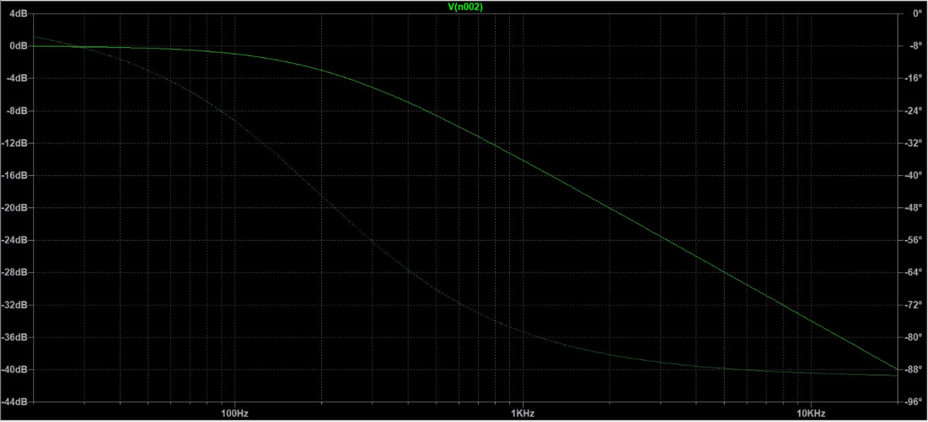

Gain and phase at

, , , ,

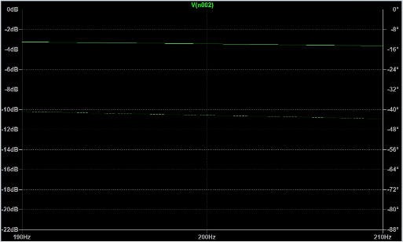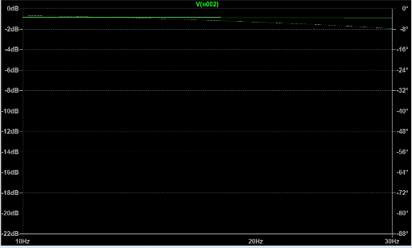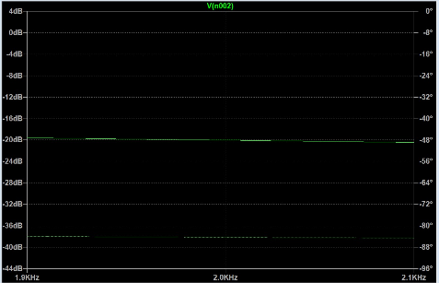

|  |  |  |
| --- | --- | --- |
|  |  |  |

At $f_{c}$– Gain is - $3 dB$, or ½ of the total power; phase is $-45°$, which lags the supply by ¼ o

At $\frac{f_{c}}{10}$– Gain is $≈0 dB$, or total power; phase is $-84°$, which lags the supply by nearly half a wavelength

At $10f_{c}$– Gain is $≈-20 dB$, which is 1/10 of total power; phase is $-6°$, which is nearly in phase with the supply

Adding a 10k resistor load

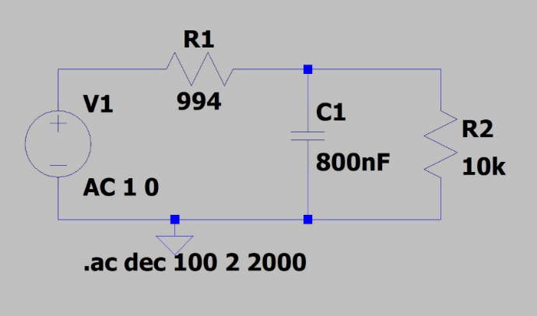

Resulting waveforms:

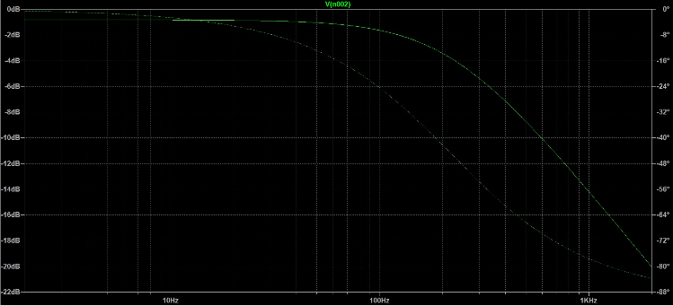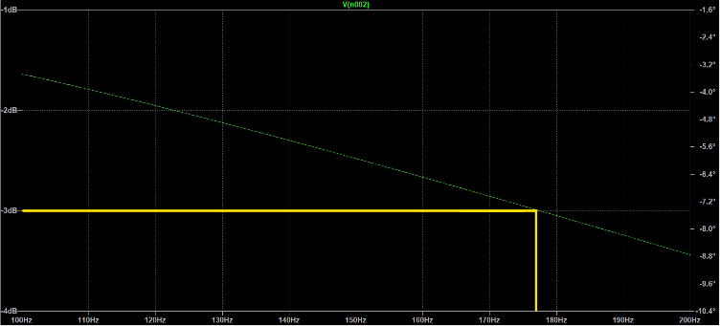

* 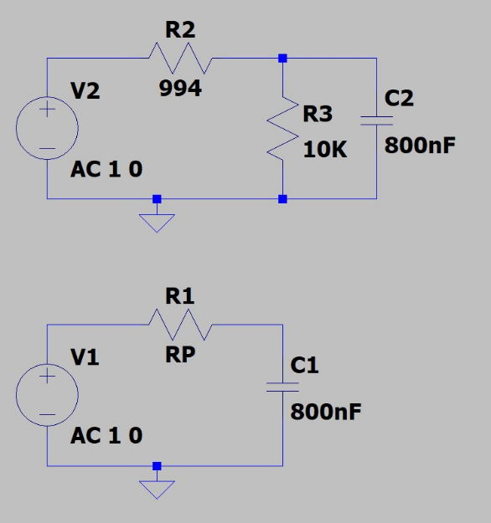Fc is changed because the filter is being affect by the Loading effect – when the impedance of the circuit is affected by the load attached. Waveform starts at -1 dB now
* To find the new cut-off frequency, the circuit can be rearranged and using Thevenin transforms and the resistor divider equation for the two resistors with $R_{p}=\frac{R_{1}⋅R_{2}}{R_{1}+R_{2}}$, it can be re-evaluated as a normal RC circuit

$$R_{p}=\frac{994.7⋅10E3}{994.7+10E3}=904.7086$$

$$ω_{c}=\frac{1}{RC}$$

$$f_{c}=\frac{1}{2πRC}$$

$$f_{c}=\frac{1}{2π⋅904.7086⋅800E-9}$$

$$f_{c}=219.8944$$

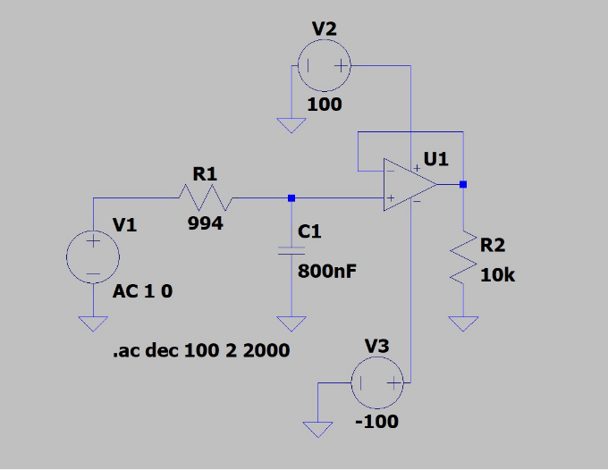Voltage Follower

Inserting a voltage follower in between the filter and 10k resistor

* Also known as a unity gain amplifier or isolation amplifier
* Output of a voltage follower is the same as the input; output is tied to the non-inverting input of ideal op-amp which forces it to always be equal to input

Finding $f_{c}$ from the graph at -3 dB:

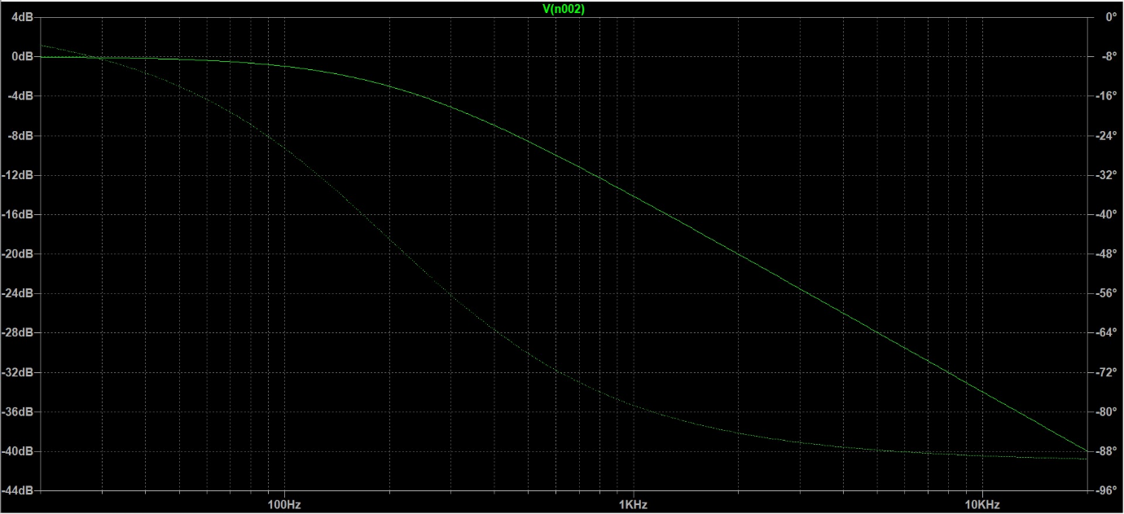

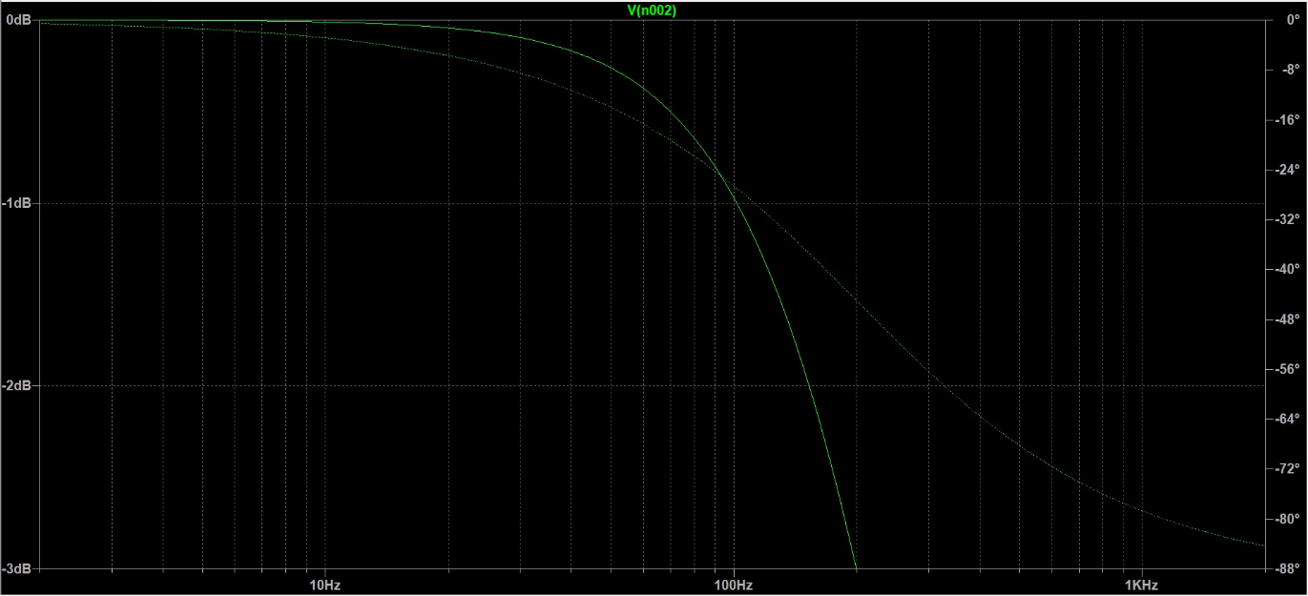

$$f_{c}≈200 Hz$$

In other words, we get the same cut-off frequency if there was no load. The reason for this is the voltage follower produces a perfect copy of the signal from the low pass filter, but also isolates it from the filter. This means that the loading effect is avoided and the filter’s frequency response is not changed.

Part 2: Audio Effects Unit

Integrator Op amp

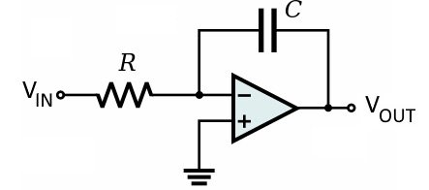

Using LM741 Op amp and inputting a 1kHz square wave signal

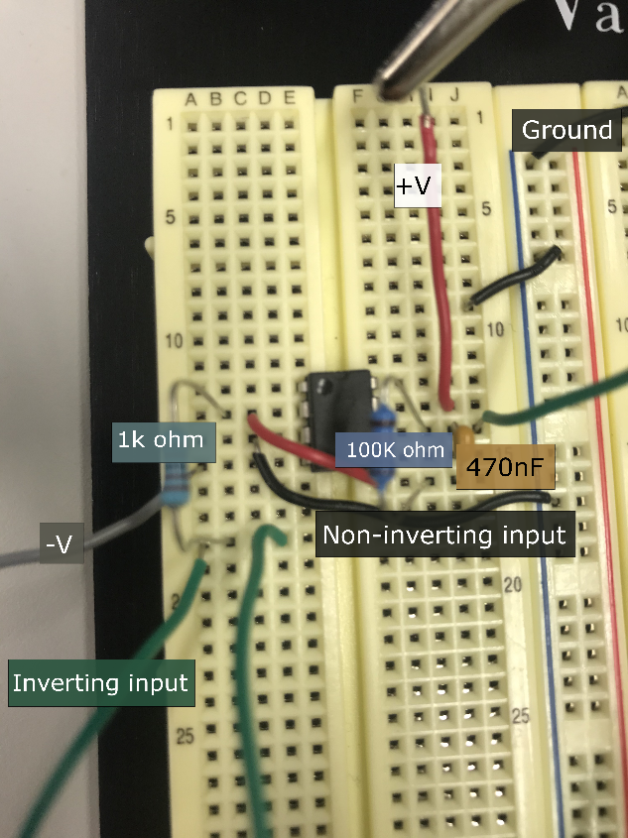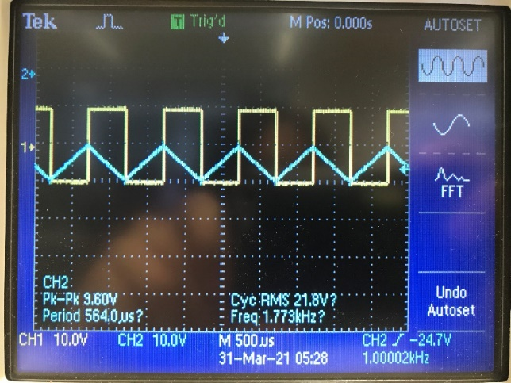

Integrator Wind-up

Adding different offsets to the Square wave signal

|  |  |  |
| --- | --- | --- |
| 0 V offset | 1 V offset | 5 V offset |
|  |  |  |

At high frequencies, it acts a short circuit, but at DC or low frequencies, the capacitor acts as an open, meaning it blocks them. If the resistor was not there, the DC voltage at the inverting inputs would not be able to get to ground, building up and eventually causing wind up. Though the offset affects the output, the 100k resistor prevents any wind up as it always provides a path to ground for any DC current to go to.

Voltage Gain

Measuring Voltage gain from oscilloscope

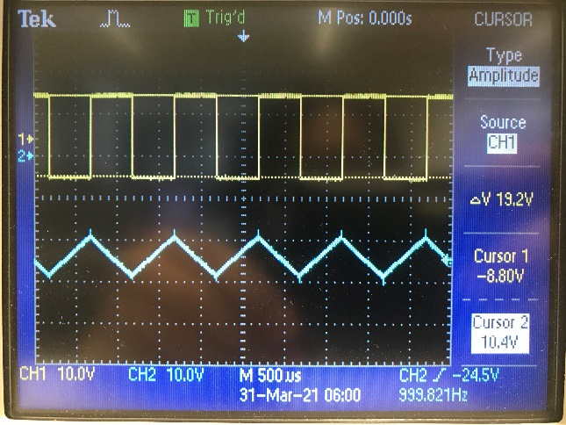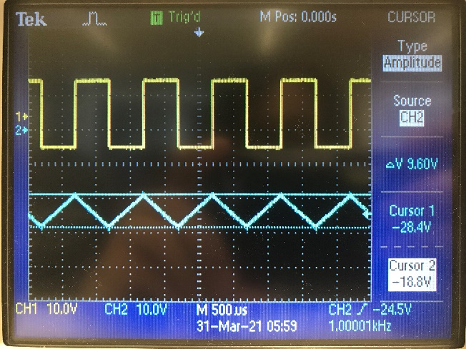

$$V_{i}=20, V_{o}=10$$

$$\frac{V_{o}}{V_{i}}=\frac{10}{20}=\frac{1}{2}$$

Therefore an op amp with gain of 2 is needed

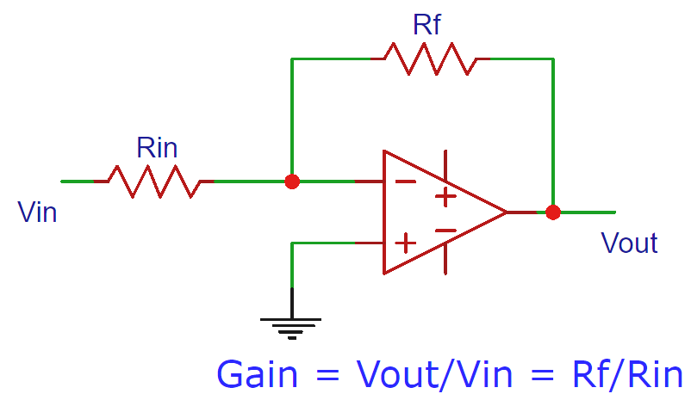

Designing the second Amplifier

The second Op amp will just be an inverter op amp; the gain for this can be calculated from:

$$G=\frac{R_{f}}{R_{i}}$$

In other words, ${2R}_{i}=R_{f}$. Using $R_{f}=100 Ω$ resistors:

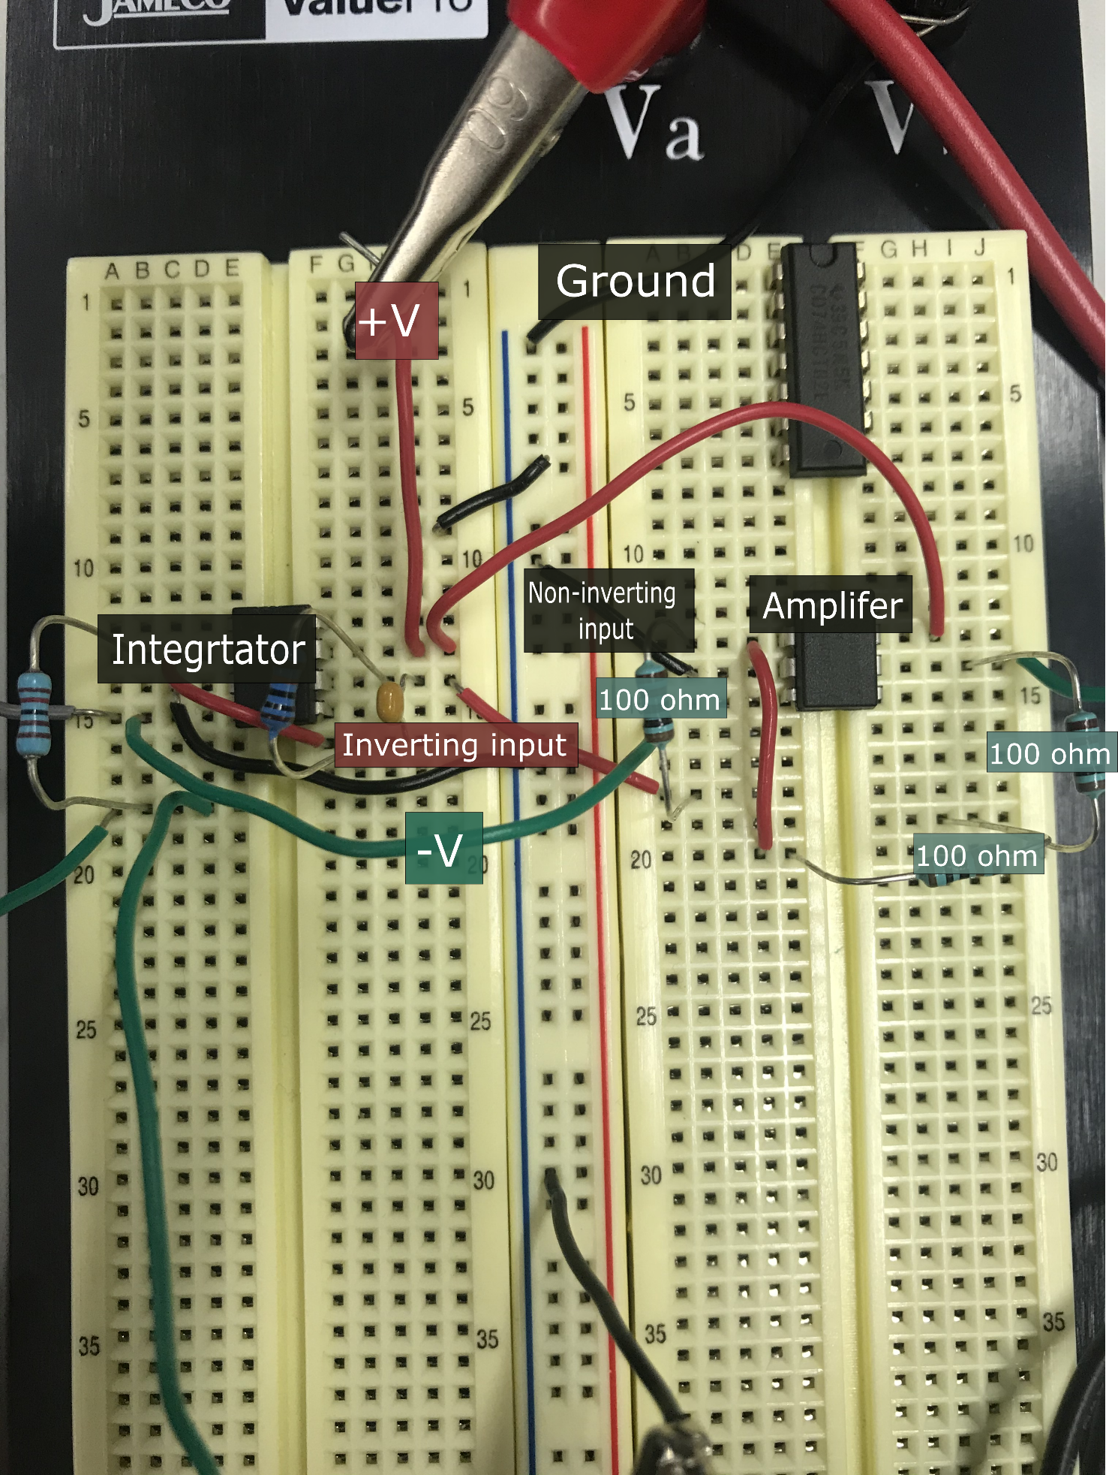

Which produces this waveform; the inverter works as design and the output amplitude matches the input

